

READING TEST

In the Reading test, you will read a variety of texts and answer several different types of reading comprehension questions. The entire Reading test will last 75 minutes. There are three parts, and directions are given for each part. You are encouraged to answer as many questions as possible within the time allowed.

You must mark your answers on the separate answer sheet. Do not write your answers in your test book.

PART 5

Directions: A word or phrase is missing in each of the sentences below. Four answer choices are given below each sentence. Select the best answer to complete the sentence. Then mark the letter (A), (B), (C), or (D) on your answer sheet.

|  |  |  |
| --- | --- | --- |
| 101. Mr. Pierce requested that all employees | 105. | As of October 1, Ms. Givens will be planning |
| meet in office at noon. |  | our department's travel --. |
| 1. himself 2. his |  | 1. budgeted 2. budget |
| (C) him |  | (C) budgetary |
| (D) he |  | (D) budgeter |
| 102. We greatly appreciate your in | 106. | Job applicants are encouraged to |
| preparing your office for the upcoming |  | submit a work portfolio and a résumé. |
| move. |  | (A) rapidly |
| (A) cooperates |  | (B) strongly |
| 1. cooperated 2. cooperation |  | 1. nearly 2. tightly |
| (D) cooperate |  |  |
|  | 107. | Join us for dinner on Friday Mr. Yi's |
| 103. Employees who to contribute to the |  | promotion to Vice President of Marketing. |
| company picnic should contact Mr. Liu. |  | (A) to celebrate |
| 1. require 2. supply 3. wish |  | 1. celebrates 2. will celebrate 3. celebrated |
| (D) express |  |  |
|  | 108. | The of 21 tools ordered will be |
| 104. Ms. Ngo will make the awards |  | delivered to the Abby Street warehouse this |
| announcement the luncheon next |  | afternoon. |
| week. |  | (A) set |
| 1. up 2. onto 3. off |  | 1. room 2. fit 3. power |
| (D) at |  |  |



|  |  |  |
| --- | --- | --- |
| 109. Galaxy Health Club offers a 20 percent discount for all classes November. | 115. | Now that Rocker Guitar School is a -------  enterprise, it can afford to hire additional |
| (A) entire |  | teachers. |
| (B) during |  | (A) musical |
| (C) while |  | (B) profitable |
| (D) ever |  | (C) comoact |
|  |  | (D) long |
| 110. the printer cartridge was installed |  |  |
| correctly, it leaked some ink. | 116. | The renovated office building did not look |
| (A) Although |  | the way Ms. Garcia it would. |
| (B) So |  | (A) imagine |
| (C) If |  | (B) imagining |
| (D) However |  | (C) imagined |
|  |  | (D) imagination |
| 111. Ms. Chu will explain how the factory workers |  |  |
| can protect equipment from damage. | 117. | Arsov Consulting advised us to wait until the |
| (A) theirs |  | ---- to ship the new line of sweaters. |
| 1. them 2. themselves |  | 1. summer 2. year |
| (D) their |  | (C) hours |
|  |  | (D) weather |
| 112. Promotional ideas for violinist Zelina Ortiz will be by the publicity team next | 118. | The heads of ------- department in the |
| month. |  | company must attend the training session in |
| (A) escorted |  | Kolkata. |
| (B) tutored |  | (A) its |
| (C) discussed |  | (B) each |
| (D) subscribed |  | 1. most 2. several |
| 113. *Giffords Global Investors Magazine*  experienced its highest numbers in ------- | 119. | Vurk Ltd., manufacturer of industrial sewing |
| sales in the last quarter. |  | machines, is to introduce a line of |
| (A) digits |  | home products soon. |
| (B) digital |  | (A) applied |
| (C) digit |  | (B) expected |
| (D) digitize |  | (C) inquired |
|  |  | (D) objected |
| 114. A new barbershop is opening the |  |  |
| neighborhood already has three others. | 120. | Reception desk personnel are thoroughly |

1. among
2. that
3. prior to
4. even though

trained to answer any that hotel

guests may have.

1. questioner
2. questioned
3. questions
4. questionable



|  |  |  |
| --- | --- | --- |
| 121. Wyckshire Mobile's unlimited talk, text, and | 126. | Gribson & Kim's brand identity |
| data plan is priced at £50.00 per |  | accurately conveys the company's image |
| month. |  | and values. |
| (A) promptly |  | (A) powers |
| (B) reasonably |  | (B) powered |
| (C) partially |  | (C) pc'verful |
| (D) loyally |  | (D) powerfully |
| 122. Khaab Staffers announced its acquisition of | 127. | The city council approved Remco's |
| an international database of 5,000 |  | application to build a shopping center ------- |
| companies sorted by location or industry. |  | opposition from local residents. |
| 1. many 2. beside 3. wide 4. over |  | 1. in spite of 2. in ordr‘.r that 3. even so 4. on the contrary |
| 123. The presence of several eagle nests makes | 128. | Marliet Marketing can help any business |
| Hilltop Grove a favorite site for bird |  | - -- its products through multimedia |
| watchers. |  | advertising packages. |
| (A) enthusiastic |  | (A) promote |
| (B) affordable |  | (B) promoted |
| (C) elaborate |  | (C) promotable |
| (D) comparable |  | (D) promoter |
| 124. The general manager has implemented a | 129. | Local reporters sought with the |
| system to fill online orders of costume |  | department manager who found old property |
| jewelry lines more ------- |  | records in the city hall basement. |
| 1. quick 2. quickest |  | 1. permits 2. materials |
| 1. quicker 2. quickly |  | 1. conditions 2. interviews |
| 125. Quillet Motors has been working the | 130. | To appeal to younger consumers throughout |
| goal of reducing its factory emissions by 25 |  | Asia, the sportswear company is shifting its |
| percent since last year. |  | marketing tactics ------- |
| (A) after |  | (A) drama |
| (B) across |  | (B) dramatic |
| (C) opposite |  | (C) dramatically |
| (D) toward |  | (D) more dramatic |

PART 6

Directions: Read the texts that follow. A word, phrase, or sentence is missing in parts of each text. Four answer choices for each question are given below the text. Select the best answer to complete the text. Then mark the letter (A), (B), (C), or (D) on your answer sheet.

Questions 131-134 refer to the following information.

Welcome to Dining-Ticket, the online service that delivers high-quality, delicious meals to your

-131a

To start : 32: Dining-Ticket, simply enter your location to view your local delivery options.

Next, filter the information by your desired price range, cuisine type, or by the restaurant name.

Then, track your order as it is transported by a Dining-Ticket delivery person -: 33: To enjoy

your favorite restaurant fare from the :34:°

f your own home, Dining-Ticket today!

try

|  |  |  |
| --- | --- | --- |
| 131. | 1. doorstep 2. station 3. program 4. market | 134. (A) comforted   1. comforting 2. comfortable 3. comfort |
| 132. | (A) usage |  |
|  | (B) using |  |
|  | 1. usable 2. users |  |
| 133. | (A) Additional delivery staff are being |  |

recruited now.

1. Your order will be ready for in-store pickup within one hour.
2. Our training is thorough and fast.
3. It's as easy as that.



Questions 135-138 refer to the following e-mail.

To: Rashida Willis [<rwiIIis@pintaur.net>](mailto:rwiIIis@pintaur.net)

From: Customer Accounts [<accounts@stauntonnaturaIgas.com>](mailto:accounts@stauntonnaturaIgas.com) Date: August 4

Subject: Paperless billing Dear Ms. Willis,

Thank you for selecting the paperless billing -: 3-5: for your Staunton Natural Gas account.

-13‹t on August 20, you will receive your monthly statement electronically. To ensure receipt of your bill, please add our e-mail address to your list of contacts. At any time you may

-137: to traditional paper billing by selecting it in your account settings.

-138: Your bill will still be due on the first of each month. Sincerely,

Staunton Natural Gas

1. (A) value
2. degree
3. project
4. option
5. (A) Until
6. Only
7. Beginning
8. Even
9. (A) return
10. returnable
11. to return
12. returning
13. (A) The account balance is now overdue.
14. Nothing else about your billing process has changed.
15. A company representative will contact

'y'OU SOOLI.

1. The account will be closed on the final day of the month.

Questions 139-142 refer to the following memo.

To: Red Division Sales Team Members From: Matias Gama, Director

Subject: Information Date: 22 November

Attachment: Third-quarter results

Let me commend all of you on your outstanding work this past quarter! See for yourselves in the

attached report, which provides all the details. -: 3 : , there's alwavs room for growth. That's why we're launching a new -14v: program. It will be provided by an outside agency that has carefully

-14›

our needs. Although the learning modules will be offered across the organization, they are

scheduled to begin in our division. -142d. In the meantime, please carry on with your good work.

1. (A) Similarly
2. In that case
3. Nevertheless
4. Even if
5. (A) radio
6. exercise
7. training
8. benefits
9. (A) analyzed
10. analyzing
11. to analyze
12. been analyzed
13. (A) This was our best quarter ever!
14. I will let you know the dates soon.
15. Our clients are very pleased as well.
16. Registration is now full.





**Questions 143-146** refer to the following e-mail.

From: Joanna Markian To: All management staff

Subject: Meeting with Adacorp leadership Date: 11 January

Dear Credulux colleagues,

Please be advised that our Wednesday Board of Directors meeting will focus on the -143. company merger with Adacorp Ltd. We will be joined by Adacorp's CEO and several managers

as well as members of both companies’ legal teams. -144:

The purpose of this meeting is to clarify the timeline of the merger process. -: 4 : with questions

for our Board of Directors will be given ample time to ask them.

-14-6-:

, I would like to request that

all nonurgent agenda items be saved for our management team meeting in early February.

Sincerely,

Joanna Markian

1. (A) selected
2. upcoming
3. occasional
4. assorted
5. (A) Please plan to attend this meeting in person.
6. Interns will report on their experience at Adacorp.
7. Instead, we will extend the meeting by one hour.
8. You will soon be notified of the new law.
9. (A) Each other
10. Yours
11. Anyone
12. Whoever
13. (A) On the contrary
14. For this reason
15. Soon after
16. For example

PART 7

Directions: In this part you will read a selection of texts, such as magazine and newspaper articles, e-mails, and instant messages. Each text or set of texts is followed by several questions. Select the best answer for each question and mark the letter (A), (B), (C), or (D) on your answer sheet.

Questions 147-148 refer to the following information.

Smith County Transportation Department Current Postings

Bridge Inspector (Bl9253)—Take your career tc taew heights as a bridge inspector in beautiful Smith C‹ unty, knr›u ti Y‹›r its s cct‹iculrw unit variec3 la14cJ5ca{oe! The geography of our county is large and hilly, necessitating the use of c›ur many bridges anc4 tunnels by residents and t‹ urists alike. The p‹›Sitic›ta inv‹o1vcs ‹assessing the cr nditir›n r›f ex istitig I ridges, tunnels, culverts, anal related rc›acI signs cis well ‹is proposing anc4 overseeing repairs. We rafter competiti› e salaries with excellent

[www.smithcounty.gov/jobs.](http://www.smithcounty.gov/jobs) The deadline is january 15.

1. What does the information suggest about 148. According to the information, what is one Smith County? duty of the bridge inspector?
   1. Its population is growing rapidly. (A) Supervising maintenance work
   2. Its tunnel system requires (B) Planning new bridges modernization. (C) Collecting bridge and tunnel tolls
   3. It is an attractive place to live and visit. (D) Designing traffic signs
   4. It is currently building many new

highways.



Questions 149-150 refer to the following notice.

Thank you for purchasing tickets for a tour of the historic Walton Steatcship. If you need to cancel c›r change yc ur appointment, please be aware of our c›incel1ation policy. Cancellations up tc› cone clay before the scheclulec4 tour will receive a refund c f 50% per ticket. Canceling c n the same day or failing te appear at the time of your schec4ulec4 tour will result in nc› refuncL All refunds null be crecJitccl to the carol usecJ to purchase the tickets.

Please nc te that tours are conclucted both insic4e the ship and c utsicle c›n deck. Tours are rarely canceled clue tc weather. Please wear appropriate c1c›thinq in c‹ise we experience cold or wet weather.

1. For whom is the notice most likely intended?
   1. Current ticket holders
   2. Steamship crew members
   3. Customer service representatives
   4. Tour guides in training
2. What does the notice recommend people do?
   1. Update their contact information
   2. Print historical reference materials
   3. Dress to spend time outdoors
   4. Arrive early on the day of the tour

Questions 151-152 refer to the following e-mail.

|  |  |  |  |
| --- | --- | --- | --- |
| L-Mail Message | | | |
|  | | | |
|  | From: | support H volunix.com |  |
|  |
|  | To: | Amrita Das <adas H mylastmail.com> |
|  | Sent: | September 6 |
|  | Subject: | Incident 030924 |
| 4| |
|  |
|  |  |  |  |
|  | Dear Valued Customer:  Thank you for contacting Volunix Ltd., the online store for medical surplies. We apologize for the technical difficulty you are experiencing with your online purchase. Your support ticket was submitted on Wednesday, September 6, at 10: 1 2 p.m. You can track the status of your incident by using the “case status” feature. You can also use this feature to add information to the ticket at any time.  The Volunix team responds to support issues as quickly as possible. During regular business hours (8 a.m. to 6 p.m., Monday through Friday), you can expect a response within one hour. Tickets submitted alter business hours and on weekends will be responded to before noon of the following business day.  Thank you,  The Volunix Web Team | |  |
|  |
|  | | |  |

1. What problem is Ms. Das most likely experiencing?
   1. Her firm's Web site is not accessible.
   2. Her computer needs a system update.
   3. She has not received a refund.
   4. She is unable to buy an item.
2. What is indicated about a support ticket?
   1. It was submitted incorrectly.
   2. It was submitted after business hours.
   3. It was resolved in one hour.
   4. It was addressed by a Volunix supervisor.





Questions 153-155 refer to the following e-mail.

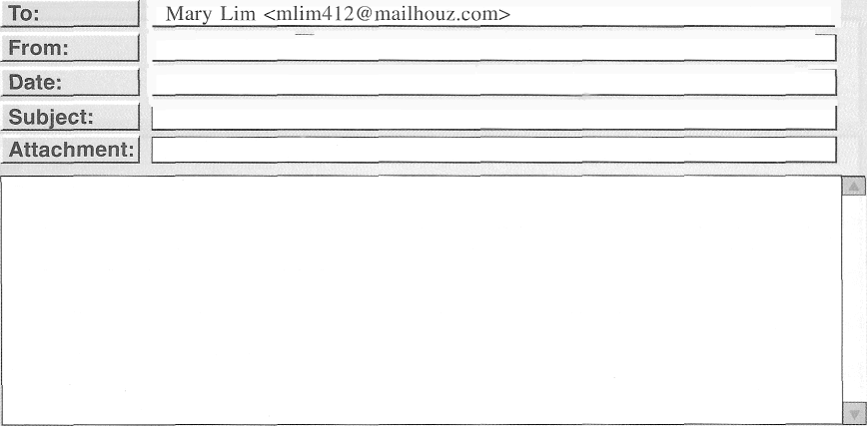

George S iskos < asiskos crehcorp.coir> September 24

Referral trom Joe Argento Infornirition

Hello Ms. Lim,

I ana George Siskos. Recruitinq• Manager at Crehcorp Ltd. We ru‘e currently’ looking to hire an acc‹iuntin clerk. and Joe Argento recoup rnetidecl you. From what Joe told me. your background makes you a good fit for the role (postinq•q attached). IN you are interested in learning more about Crelacor[a and the position, I will be happy t‹ provicle turthei information. Let me know when you are available to talk, and I will give you a call.

I look for ward to hearin* back 1 roni you!

1. What is the purpose of the e-mail?

# To advertise for Crehcorp

* 1. To request a reference
  2. To recruit an employee
  3. To announce a promotion

1. What does Mr. Siskos attach?
   1. A job description
   2. A financial report
   3. A conference invitation
   4. A link to driving directions
2. What is Ms. Lim asked to do?
   1. Visit Crehcorp's Web site
   2. Contact Mr. Argento
   3. Mail a résumé
   4. Respond to the e-mail

Questions 156-157 refer to the following text-message chain.

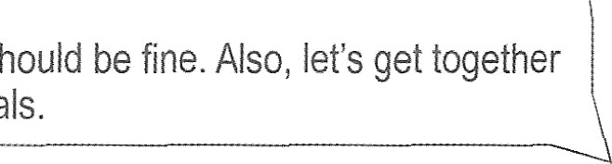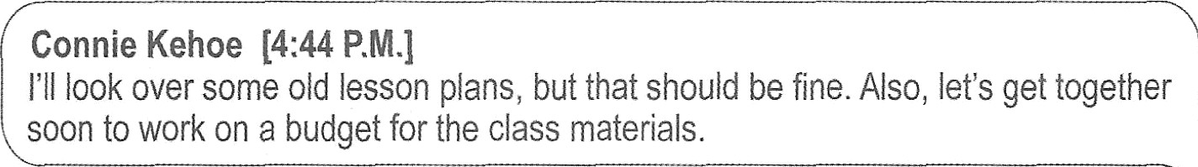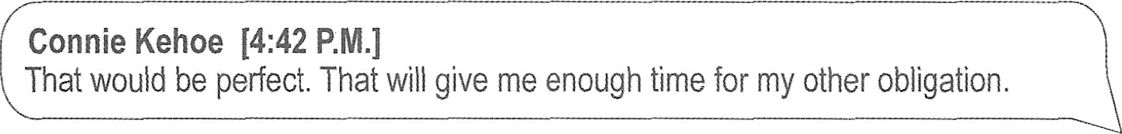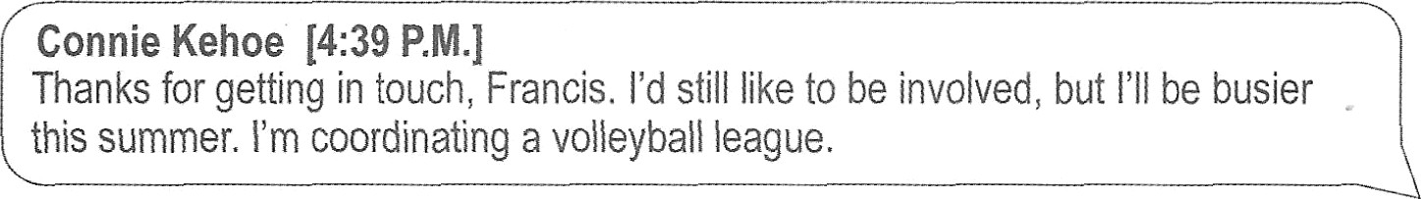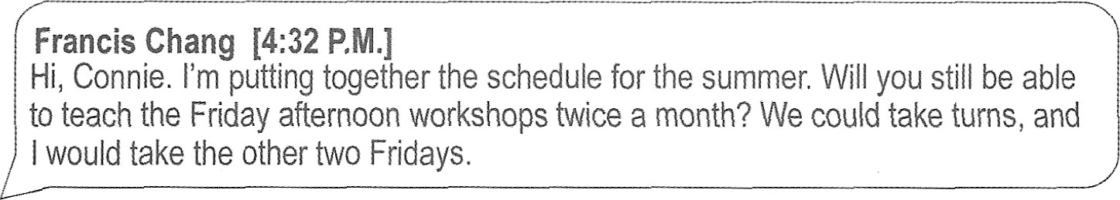

Francis Chang [4:40 P.M.]

Well, OK. I guess I could cover the workshops three Fridays a month.

Connie Kehoe |4:42 P.M.]

That would be perfect. That will give me enough time for my other obligation.

Francis Chang [4:43 P.M.)

The other thing is, this summer we want to focus on painting with watercolors,

rather than basic drawing.

Connie Kehoe [4:44 P.M.]

I'll look over some old lesson plans, but that should be fine. Also, let's get together soon to work on a budget for the class materials.

Francis Chang [4:32 P.M.]

Hi, Connie. I'm putting together the schedule for the summer. Will you still be able to teach the Friday afternoon workshops twice a month? We could take turns, and I would take the other two Fridays.

Connie Kehoe |4:39 P.M.]

Thanks for getting in touch, Francis. I'd still like to be involved, but I'll be busier this summer. I'm coordinating a volleyball league.

1. At 4:42 P.M., what does Ms. Kehoe mean when she writes, “That would be perfect"?
   1. She is looking forward to summer.
   2. She thinks a workshop will be popular.
   3. She is happy with a proposed schedule.
   4. She is glad that Mr. Chang will be hired.
2. What type of workshop is being planned?
   1. Art
   2. Personal finance
   3. Travel
   4. Customer service



Questions 158-160 refer to the following letter.

May 15

Mr. Roger Lang, Executive Director Parker Solutions Foundation

40 Northside Drive, Suite 500

Portland, OR 97215

Dear Mr. Lang:

The purpose of this letter is to invite you, on behalf of the board of directors, to be the keynote speaker at the International Green Solutions Research Institute (IGSRI) Conference. — [1] —. It will be held at the Fairview Conference Center in Saint Louis, Missouri, from December 3 to 5. You were recommended by a number of my colleagues. — [2]

Professor Suzanne Benedetto will deliver the opening speech on the morning of December 3. A draft program will be sent to you in two weeks to give you an idea of the topics that will be highlighted at the conference.

We expect attendance this year to be the highest ever, around 2,500 delegates and 40 speakers. — [3] —. This includes a large contingent from our newest chapter in Geneva. — [41 —

I hope to contact you in a week to follow up and answer any questions you may have.

Yours sincerely, Brian Morgan

1. Why was the letter to Mr. Lang written?
   1. To request a recommendation letter from him
   2. To ask him to evaluate some conference topics
   3. To congratulate him for receiving an award
   4. To ask him to participate in a conference
2. In what city will the IGSRI Conference be held?
   1. Portland
   2. Fairview
   3. Saint Louis
   4. Geneva
3. In which of the positions marked [1], [2], [3j, and [4] does the following sentence best belong?

“They spoke highly of your expertise.”

(A) [1]

# (B) [2]

(C) [3]

# (D) [4]

Questions 161-163 refer to the following Web page.



|  |  |  |
| --- | --- | --- |
| [www.sergeyparksandrec.gov/survey](http://www.sergeyparksandrec.gov/survey) | | |
|  | Welcome!  You have been directed to this survey through a page on the Sergey Parks and Recreation Department's Web site, front one of Ecology Alive's most recent online newsletters, or from a friend's social media page. Regardless of how’ you got here, we appreciate youi taking the time to complete it.  This survey aims to help local wildlife organizations find practical approaches to attracting a dedicated and reliable volunteer base. The survey takes about 15 minutes to complete, and your participation is completely optional. If you do not wish to answer a particular question, you can move on to the next onc.  If you have any questions regarding how this survey will be used. please contact Stefan McHann at stefan mchann O sergeyparksandrec.gov.  Survey #4123  Name: Kenshawn Odeyemi |  |
|  |
|  |  |  |

1. What is indicated about the survey?
   1. It was recently modified.
   2. It can be accessed from multiple online sources.
   3. It requires an hour to complete.
   4. It is being sent only to university students.
2. What is the purpose of the survey?
   1. To find ways to recruit volunteers
   2. To evaluate an organization's strengths
   3. To assess an area's wildlife populations
   4. To determine important leadership traits
3. What is suggested about the survey respondents?
   1. They can skip some of the questions.
   2. They must subscribe to Ecology Alive.
   3. They will be paid for their participation.
   4. They will receive an additional survey

# from Mr. McHann.

Questions 164-167 refer to the following notice.



December I

At en to fi1 E lo ees:

J3eginn ink can {tiiiuar} 1, Barlfiey-Steplacns Corporation (BE €?) o‘ill transition to a security system that uses integrated IU badges. Until now, BSC employees have used traditi‹›na1 identification carcls that security personnel checked at entrances

I

to the building. They simply comparcd the badge photograph with the employee's appearance. The new system will be more technologically rtclvanced, integrating ID badge information with arious access points around our âacilip:



Integrated III badges allow employees entry only to .ii eas of the building that are permitted to them. Moreover, the badges create an electronic record of who has entered which area.s of the 1 uilding and when. In the case of temporary ein{aloyees, badges u‘ill be disabled when their tenttre ends.

New pliotosraphs of all staff will tae taken in mid-December, when ever yone will *be*

asked to fill out a brief form to complete badge proccssin .

1. What is the purpose of the notice?
   1. To ask employees to submit information
   2. To encourage greater use of the facilities
   3. To discuss renovations to a building
   4. To announce security system changes
2. The word “points” in paragraph 1, line 6, is closest in meaning to
   1. purposes
   2. details
   3. places
   4. moments
3. What is a stated advantage of the new ID badges?
   1. They fit conveniently into a pocket.
   2. They allow access to additional areas of a building.
   3. They are more durable than the older ID cards.
   4. They can track an employee's location on-site.
4. According to the notice, what feature of the current IDs will be updated?
   1. The photo
   2. The company logo
   3. The shape
   4. The employee's job title

Questions 168-171 refer to the following online chat discussion.

|  |  |  |  |
| --- | --- | --- | --- |
|  | | | |
| Franklin Smith (7:51 A.M.)  Good morning, Josephine and Carl. Is either one of you at the office yet? My train is running late and I want to make sure everything is set up for our 8:30 A.M. workshop.  Josephine Mallian (7:56 A.M.)  I'm walking in now. What can I do to help, Franklin?  Carl Domingo (7:57 A.M.)  I’ll be there in about ten minutes. Are you talking about the workshop in the Aster Room? Because there iS another workshop taking place in Obell Hall too.  Franklin Smith (7:59 A.M.)  Yes, the one in the Aster Room—the Sawy Steel sales workshop. I would appreciate it if you would rearrange the seats into a circle, turn on the projector, and run through the presentation slides I sent last night, just to make sure that everything, including the audio, is working.  Carl Domingo (8:02 A.M.)  Got it. I actually set the chairs up last night.  Josephine Mallian (8:04 A.M.)  Thanks, Carl. Would you mind printing out fifteen copies of the agenda while I take  care of the rest?  Carl Domingo (8:05 A.M.)  Sure. I'll get it done as soon as possible.  Franklin Smith (8:07 A.M.)  Thank you both. My train is arriving now. I think I'll make it in time.  Josephine Mallian (8:08 A.M.)  No problem, Franklin. We will also make sure there is plenty of coffee for you! | | |  |
|  |  |  | |

Ms. Mallian.

|  |  |  |
| --- | --- | --- |
| 168. Why did Mr. Smith send the first message? | 170. | At 8:02 A.M., what does Mr. Domingo most |
| (A) To extend an invitation |  | likely mean when he writes, “Got it”? |
| (B) To request some help |  | (A) He will check some equipment. |
| (C) To apologize for a mistake |  | (B) He will unlock the Aster Room. |
| (D) To confirm a travel reservation |  | 1. He will bring some more chairs. 2. He will revise the meeting's agenda. |
| 169. What is suggested about the Savvy Steel meeting? | 171. | What is Mr. Domingo asked to do? |
| 1. It is being moved to a different location. 2. It is one of two meetings taking place |  | 1. Bring coffee to his coworkers 2. Make changes to some slides |
| on the same day.  (C) It will include a presentation by |  | 1. Meet Mr. Smith at the station 2. Make some copies |

* + 1. It will start later than planned.

Questions 172-175 refer to the following letter.



**£oxtail Airlines**

July 30

Ms. Gina Carracia General Manager Obsidian Villa

1121 Marine Boulevard

Seattle, WA 98101 Dear Ms. Carracia:

My raine is Isaac Bretton, and I am Director of Marketing at Foxtail A irlines.

* + - 1. —. I am writing to share a marketing Idea with you that would be beneficial for Sr th our companies. Our crew members who fly into Seattle have stayed at Obsidian Villa several times in the past. They report that the rooms are consistently comfortable and clear and that the staff is friendly and efficient. — [2] —. H‹ wever, there is often no vacancy at your excellent establishment, and so our crews trust stay elsewhere. We have arrangements with hotels in several cities arc urtd the world in which rooms are reserved for our crews in advance. Foxtail Airlines advertises for these hotels in our in-flight magazine at a significant discount. — [3] —. We would like tc develop a similar partnership with Obsidian Villa.

To give yrau are iclea of the aclvertising possibilities we r›ffer, our graphic c4esign team has created Your potential advertisements. They are enclosed with this letter.

— [4] —. I hope these samples demonstrate h‹ w enthusiastic we are aloout promoting Obsidian Villa tc› the over three million passengers who fly with us every year. If ycau are interested in exploring this idea further, please contact me by phone at

546-555-0182 or by e-mail at i.r.bo1tonAfoxtailair1ines.com. I hope to have the opportunity to work with you.

Sincerely,

Isaac Bolton, Director elf Marketing Foxtail Airlines

Enclosures

1. What is the purpose of the letter?
   1. To introduce a product
   2. To make a reservation
   3. To propose a new partnership
   4. To announce a promotion
2. What is indicated about Obsidian Villa?
   1. It usually has rooms available.
   2. It recently hired additional managers.
   3. it has three million customers a year.
   4. It provides good customer service.
3. What did Mr. Bolton send with the letter?
   1. Sample advertisements
   2. An in-flight magazine
   3. Airline tickets
   4. A client's itinerary
4. In which of the positions marked [1], [2], [3], and [4] does the following sentence best belong?

“I have read numerous positive reviews that say the same."

(A) [1]

(B) [2]

(C) [3]

(D) [4]





Questions 176-180 refer to the following schedule and e-mail.

**Monthly Reading** Series at the **Spotted** Cat **Bookstore**

**June Schedule**

Saturday, June 2 Brian Stenick, author of *Into the Sea.’ Collected Poems* Sunday, June 3 David Callander, author of *The Masters* o{Co i/ord Monday, June 11 Nina Brown, author of *NHi?ii/ Threads*

Wednesday, June 13 Bernice Sandene, author of *fie/roac/ive. A Histoi y ofAthletic Wear*

Readings begin at 7:00 P.v.. and there is a reception with light refreshments afterward.

If you are a published writer interested in reading for our series this July, please submit a five-page example of your work as an attachment to readings mspottedcatbooks.com. With your writing sample, send a one-paragraph biography. Your bio should mention your

 education and artist residencies. publications, readings, and lectures, if applicable. The series welcomes both well-established and emerging writers.

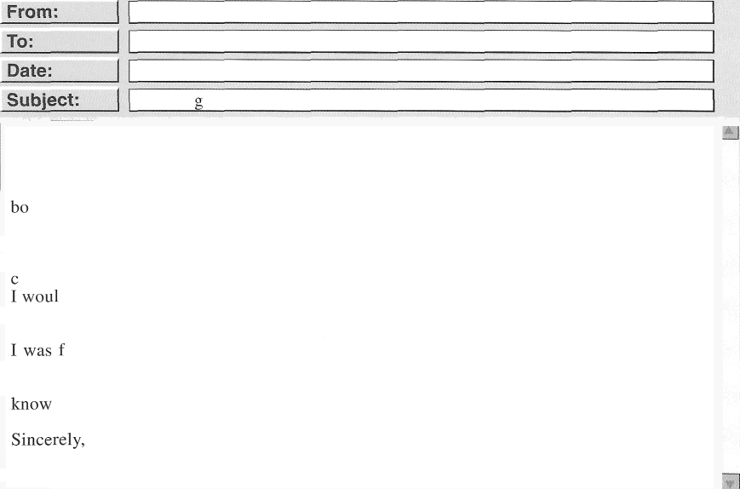

Jo Ann Rodcliff <jrodcliilH weeklycourier.com> David Callander <dca1lander H elwyn.edu>

May 1 6 Readin

Dear Professor Callander,

1 heard that you and Professor Sandene are reading at the Spotted Cat in a few weeks.

How exciting! I am hoping to attend both readings and am looking forward to seeing you

th again.

Since graduating from Elwyn University last year, I’ve been workin* for the

*Weekl› Courier* as an arts and culture columnist. Mostly, I write reviews on art shows, oncerts, and other cultural events around the city. I also write profiles and book reviews.

d like to ask whether I may texture you and your book in my next column. The column will be published the day before your reading.

ascinated by your book, and it would be my pleasure to review it in the

*lVeeLl v Cota-ter.* Are you available for a phone call tomorrow? Of course, I would prefer to interview you in person, but I’m out of town on assignment until next week. Please let me

if you are interested.

Jo Ann Rodcliff

1. What is stated about the reading series?
   1. It is held once a month.
   2. It features both new and well-known writers.
   3. It requires a ticket to attend.
   4. It highlights recently published books.

179. On what date does Ms. Rodcliff hope to hear Professor Sandene read?

1. June 2
2. June 3
3. June 11
4. June 13
5. What should writers send to the bookstore? 180.
   1. Information about their background
   2. A book they would like to read to customers
   3. The location at which they prefer to lecture
   4. A signed contract
6. Why did Ms. Rodcliff write the e-mail?
   1. To introduce herself to a new client
   2. To describe her experience to a potential employer
   3. To arrange an interview as part of her work
   4. To schedule a visit to a university

What book does Ms. Rodcliff want to review in her column?

1. *Into the Sea: Collected Poems*
2. *The Mastery of Comfort*
3. *Family Threads*
4. *Retroactive: A History of Athletic Wear*





Questions 181-185 refer to the following Web page and e-mail.



Kerilyn Fashions—Exceptional Apparel for Your Company's Brand

Are you an apparel retailer seeking products that you can rebrand as your own? We offer shirts, pants, shoes, and fashion accessories as a business-to-business wholesaler. Shop our extensive catalog and choose products for your customer base. We will badge thc products in your order with sewn-in labels carrying your company's branded 1op•o. Your order will arrive in three to four weeks.

Kerilyn Fashions saves you time in product production so that your merchandise gets to market quickly. And we offer fresh, new designs every season; sample items can be sent to you upon request.

We extend discounts on large orders. We ship anywhere in the world, with charges that are based on the weight of the order.

Merchandise is nonrefundable, and a credit will be issued for any items that arrive damaged. To get started with your first order, you are invited to set up an online account. You will be assigned an account manager who will contact you within 24 hours and facilitate your first and future orders.

|  |  |  |
| --- | --- | --- |
| To: | Terrence Anderson <tanderson Hkerilynfashions.com> |  |
|  | Sandeep Baliga <sbaligaH baligadesigns.in> |  |
|  | l ñ August  En uiry for new order |  |
| Dear Mr. Anderson,  Thank you very kindly for so effectively facilitating our very first order last month from Kerilyn Fashions—the cotton blend T-shlrtS. They were well made, and our customers liked them so much that we sold out in two weeks. We would like to request the same items, but we anticipate needing a larger quantity. What order amount is required for us to receive discount pricing? Thank you in advance for a speedy response.  Kind regards,  Mr. Sandeep Baliga | |  |
|  | |

1. What is indicated about Kerilyn Fashions? 184.
   1. It is a family-run company.
   2. It offers overnight shipping.
   3. Its prices are competitive.
   4. Its product selection is updated regularly.
2. What is NOT a stated advantage of Kerilyn 185.

Fashions' service?

* 1. It can provide sample products to examine in advance of ordering.
  2. Shipping charges are waived on large orders.
  3. Merchandise arrives at a client's business prelabeled.
  4. It assigns special managers to assist new clients.

1. Who most likely is Mr. Anderson?
   1. A fashion model
   2. A fashion designer
   3. An account manager
   4. An office supervisor

In the e-mail, the word “anticipate” in paragraph 1, line 4, is closest in meaning to

1. expect
2. prevent
3. look forward to
4. depend on

What is mentioned by Mr. Baliga?

1. His firm is planning to open branch locations.
2. His stock of T-shirts was too large.
3. He ordered T-shirts in several colors.
4. He believes Kerilyn Fashions' goods are of high quality.





Questions 186-190 refer to the following sign, receipt, and e-mail.

BETH'S SECONDHAND FURNiTun E

Hold Rules

1. Purchased merchandise can be held for 7 days.
2. Merchandise unclainied after 7 days will be returned to inventory and resold.
3. We are not responsible for damage to items that are awaiting

collection.

1. We will provide de1iv'ery services for large furniture on request. Large furniture is considered 25 kg or heavier.
2. All sales are tinal.

L



RECEIPT

@ETH*S SECONDHANci Fu»NiTUItE

Item Number: 79Z75 Receipt Number: 477Iz Weight: IB kg

Date of Purchase: 8 August Customer Name: Edward Hasegowo Total: *$I5GOO*

Payment Method: Credit had

Note: Please hold for pickup.

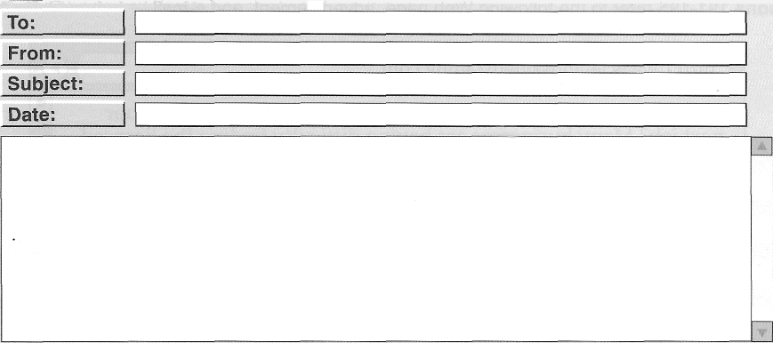

Customer Service <customerserviceHbethssecondhand.ca> Edward Hasegawa <e.hasegawaH abodemai1.com> Furniture pickup

10 August

My name is Edward Hasegawa. On Tuesday, 8 August, 1 bought a desk from your store. I planned to borrow my coworker's truck to pick up the desk, but today I learned that his truck will be in the repair shop for the next two weeks. I'd like to ask whether the hold time can be extended because of these unforeseen circumstances. I have been a long-time customer of your store and have purchased sofas, shelving•, a kitchen table, and other items.

Sincerely, Edward

1. According to the sign, what happens to unclaimed furniture?
   1. It is made available for sale again.
   2. It is donated to a local charity.
   3. It is promptly disposed of.
   4. It is moved to long-term storage.
2. What is suggested about Beth's Secondhand Furniture?
   1. It is under new management.
   2. It does not accept returns.
   3. it is a nonprofit business.
   4. It is opening another location.
3. What is indicated about Mr. Hasegawa's purchase?
   1. It cost less than $100.
   2. It must be picked up within two days.
   3. It had a reduced price because of damage.
   4. It is not considered large furniture.
4. What most likely is item number 39235 ?
   1. A couch

# A desk

* 1. A shelving unit

# A table

1. What is the purpose of the e-mail?
   1. To schedule a delivery time
   2. To confirm a purchase amount
   3. To request an extension for a hold
   4. To ask about making an item exchange





Questions 191-195 refer to the following Web page, advertisement, and e-mail.



Do you need skilled residential or commercial plumbers for your next job? Many businesses are having difficulty *tio Aio g* the licensees plumbers they need. According to a recent survey, the demand for licensed plumbers will increase by 20 percent in the next ten years.

Leland Skilled Staffing can help you find a certified plumber, saving you time and money in recruitment. Whether your project is

long-term or you need workers to handle an emergency plumbing situation, we provide on-demand skilled workers u*ith a range or expertise. We confirm the background and experience of the workers, so you can focus on your business.

Contact us today so we can help meet your staffing needs.

m

ct p w w oe a ds i edstaming

LICENSED PLUMBER

Huang Services

Job Title: Residenfiaf Plumber

Position Summary: Full-time position available at newest location in Springfield. Perform work in both new construction and existing homes, which includes servicing, repairing, and replacing plumbing, fixtures, and gas pipes.

Position Requirements: Plumbing license; 3 years' experience; driver's license; ability to use modem technology.

Pay Scale: $50,000—$90,000, depending on experience. Paid time off.

Work Hours: Vary according to seasonal needs. Some evening work required.

Send resume to s.huangAhuangservices.corn. We will contact those who pass a thorough background check to schedule an interview.

To:

Fr :

ate:

**Subject:**

info H1e1andskilledstaffing.com s.huang Ahuangservices.com April 15

Staff needed

To Whom It May Concern,

I ant writing because I am seeking a residenti‹il plumber for my business. I have had a job advertisement posted for a while now but have not had success in finding the right candidate. We require that the candidate have a plumbing license and will accept two years of experience. The candidate will also need a driver's license and be available to occasionally work evening hours. Could you please send me a list of people who would be able to start on Monday, May 5‘? My business will begin installing the plumbing in a new housing development in the area on that day.

Regards,

Stephanie Huang



|  |  |  |
| --- | --- | --- |
| 191. According to the Web page, what is expected to increase? | 194. | What does Ms. Huang mention about a job posting? |
| (A) The time for training |  | (A) It was not successful. |
| 1. The price of equipment 2. The cost of labor 3. The need for skilled plumbers |  | 1. It will soon be deleted. 2. It did not contain the correct information. |
|  |  | (D) It was posted on a popular Web site. |
| 192. What does the advertisement suggest about Huang Services? | 195. | What has changed about the position at |
| (A) It has been in business for three years. |  | Huang Services? |
| 1. It is closed during certain seasons. 2. It has only part-time work available. 3. It has more than one location. |  | 1. The starting salary 2. The number of licenses needed 3. The work hours |
|  |  | (D) The required years of experience |
| 193. What do Leland Skilled Staffing and Huang |  | |
| Services have in common? |
| (A) They were both founded by Ms. Huang. |
| (B) They are located in Springfield. |
| (C) They verify workers' qualifications. |
| (D) They specialize in commercial |

plumbing.



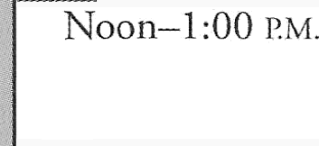Questions 196-200 refer to the following article, schedule, and e-mail.

**New Conference Scholarships from Wenford Technologies**

(Jan. 2)—Wenford Technologies, an industry leader in Internet services, has announced that it will offer six scholarships to qualified candidates to attend the Breakthroughs in Computer Science Conference in Newark, New Jersey, from April 21 to 23. To encourage a greater global perspective among conference participants, two individuals each from Latin America, Africa, and Asia will be selected as scholarship recipients.

“We believe that a variety of perspectives is what helps our industry grow and thrive,” explained Wenford Technologies' CEO Dale Kelvin. “To this end, we would like to extend this opportunity to professionals from certain geographic regions.”

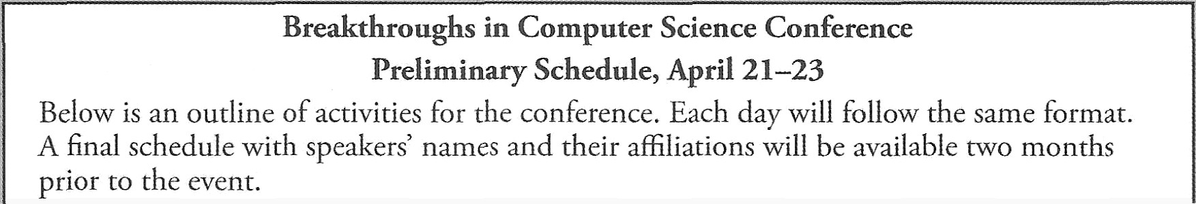Applicants must be employed full-time in computer science for a period of between one and live years in order to be eligible. For more information about the scholarships, visit wenlordtech.cont/scholarships.

|  |  |
| --- | --- |
| Breakthroughs in Computer Science Conference  **Preliminary** Schedule, **April 21—23**  Below is an outline of activities for the conference. Each day will follow the same format. A final schedule with speakers' names and their affiliations will be available two months prior to the event. | |
| 8:30 A M.—9:00 A.M. | Continental breakfast—Food will be available in the reception hall. |
| 9:00 A.M.—9:30 A. I. | Announcements |
| 9:40 A.M.—Noon | Presentations |
| Lunch break—Conference attendees will be on their own. There are many reasonably priced dining establishments within walking distance of the conference venue. | |
| 1:00 r.v.M:00 P.M. | Workshops |
| 4:00 P.M.—b: l b PM. | Panel discussions and session evaluations |
|  | |

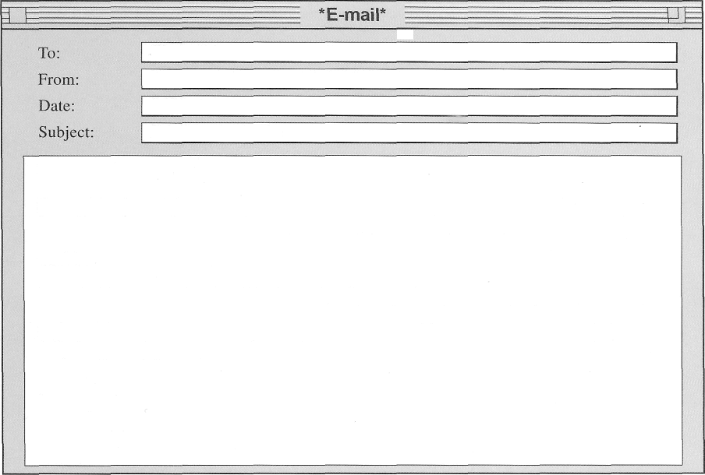

Cindy Connelly <cconnelly H wenlordtech.com> Adamu Adebayo <aadebayo Hspmail.co.za>

3 February Scholarship thanks

Dear Ms. Connelly,

Sincere thanks to Wenford Technologies for supporting my attendance at the Breakthroughs conference. It is an exciting opportunity for me, and I am really looking forward to learning trom others in the same field who work in different parts of the world.

I would like to mention that I lead a daily client conference call at 2:30 P.M. (the time in Johannesburg) that I am unable to cancel. This task would start at 9:30 A.M. in Newark, and it will require my attention for 30 minutes or so. Otherwise, I hope to participate fully in all conference proceedings. Please let me know if there is any information you might still need irom me.

Best regards, Adamu Adebayo

1. What does Wenford Technologies want to 199. What can be concluded about promote with the scholarships? Mr. Adebayo?
   1. Rapid growth (A) He works in the field of computer
   2. Collaborative work science.
   3. Diverse perspectives (B) He received a job offer from Wenford
   4. Innovative problem-solving Technologies.
      1. He hopes to acquire some international
2. According to the article, what is expected of scholarship applicants?
   1. They must respond to an online survey.
   2. They should propose workshop topics.
   3. They must select conference sessions in advance.
   4. They should be at an early stage of their careers.
3. What does the schedule suggest about the conference?
   1. It will provide a catered lunch each day.
   2. It is still finalizing some details.
   3. It relies on volunteers to lead discussions.
   4. It will vary in format each day.

clients.

* + 1. He completed his professional training in Newark.

200. During which part of the conference will Mr. Adebayo be absent each day?

1. Breakfast
2. Announcements
3. Presentations
4. Panel discussions

**Stop! This is the end of the test. If you finish before time is called, you** may **go**

back to Parts 5, 6, and 7 and check your work.